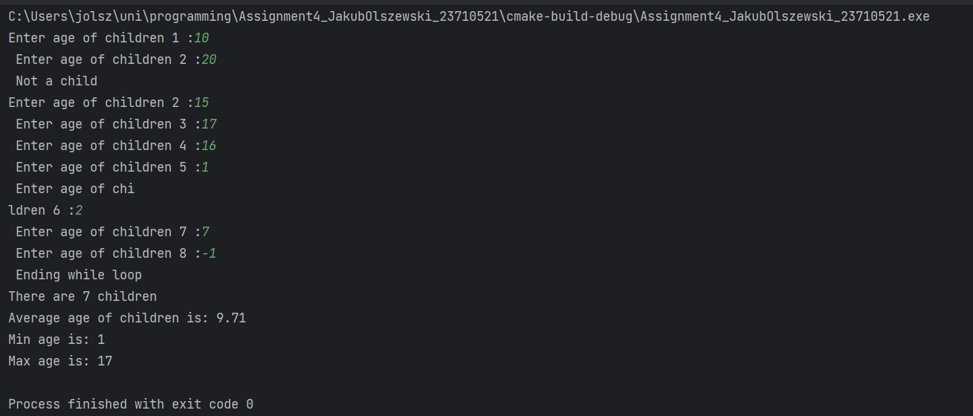

#include <stdio.h>
int main() {
int numberOfChildren = 0;
int ageSum = 0;
int currentAge = 0; // Current age is used to check for conditions and rest of calculations, so it can not be short int , because it is not limited by condition
short int minAge = 18; // We can user short int, because age is always positive and we have condition limiting age to 18
short int maxAge = 0;// We can user short int, because age is always positive and we have condition limiting age to 18
while (currentAge >= 0) {
printf("Enter age of children %d : ", numberOfChildren + 1);
scanf_s("%d", &currentAge);
if (currentAge >= 0 && currentAge < 18) {
ageSum += currentAge;
numberOfChildren++;
if (currentAge < minAge) // Checking for min age
minAge = currentAge;
if (currentAge > maxAge) // Checking for max age
maxAge = currentAge;
}
if (currentAge < 0) { // If current age is negative, we end the loop
printf("Ending while loop\n");
}
// If current age is 18 or more, we print that it is not a child and ignore imputed value
if (currentAge >= 18) {
printf("Not a child\n");
}
}
printf("There are %d children\n", numberOfChildren);
float avarageAge = (float) ageSum /
(float) numberOfChildren; // We need to cast to float, because we want to get float result.
printf("Average age of children is: %.2f\n", avarageAge);
printf("Min age is: %d\n", minAge);
printf("Max age is: %d\n", maxAge);
return 0;
}

